Experiment-25
Aim:
To write a Prolog program to implement the Monkey Banana Problem, where a monkey has to reach the bananas hanging from the ceiling by moving a box and climbing on it.
Algorithm:
- Start
- Represent the initial state of the monkey:
  - Monkey is at the door.
  - Monkey is on the floor.
  - Box is at the middle.
  - Monkey does not have the banana.
- Check whether the monkey is under the banana.
- If not, walk towards the box/banana position.
- Push the box to the position directly under the banana.
- Climb onto the box.
- Get the banana.
- Change the state to indicate that the monkey has the banana.
- Check the goal state.
- If the monkey has the banana, display the sequence of actions.
- Stop.
Code:
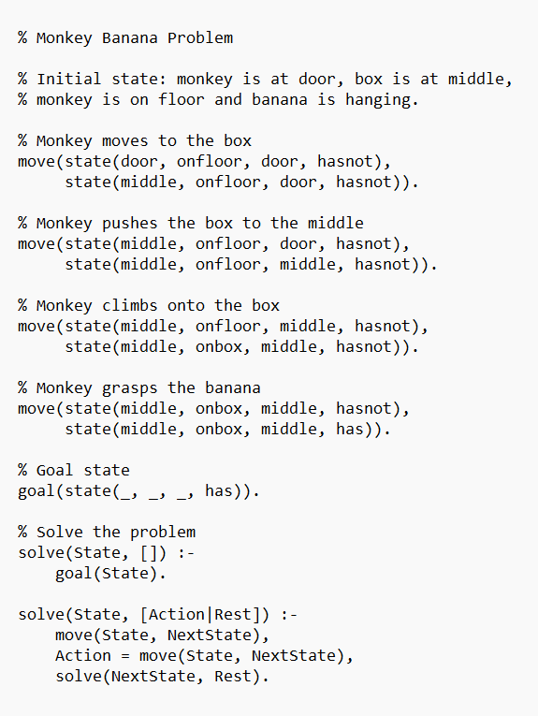
Output:
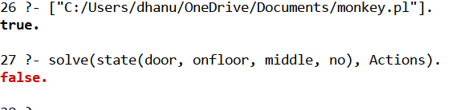
Result:
Thus the Prolog program to implement the Monkey Banana Problem has been executed successfully.

